Blender MMD 导入 3DS Max 取消 Dummy 法则
Blender MMD to 3DS Max: The No-Dummy Rule
这份说明展示如何避免 FBX 骨骼在 3DS Max 中被解释为 Dummy/Helper。
This guide shows how to keep FBX skeletons as real Max bones instead of Dummy/Helper nodes.
一、原始 FBX 导入结果 / 1. Original FBX import result
Blender 原生导出的无标题.fbx 直接导入 3DS Max 时，骨骼可能被转换为 Dummy/Helper，视图会出现大量方框、连线或异常大的显示形体。
When the Blender-exported untitled.fbx is imported directly into 3DS Max, the skeleton may be converted to Dummy/Helper nodes, producing boxes, links, or oversized display shapes.
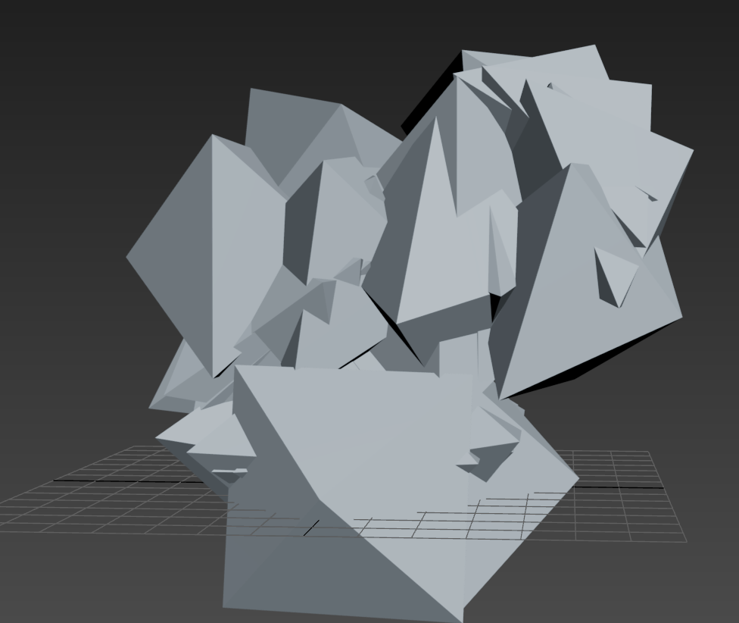
图 1 / Figure 1

二、MAX 导入设置 / 2. MAX import setting
在 FBX Importer 的 Bone Creation / Bone Conversion 中选择 Leave as bones，不要选择 Convert as dummy。若使用预设，也要确认 BoneAsDummy 显示为 Leave as bones。
In the FBX Importer, set Bone Creation / Bone Conversion to Leave as bones, not Convert as dummy. When using a preset, verify that BoneAsDummy is set to Leave as bones.
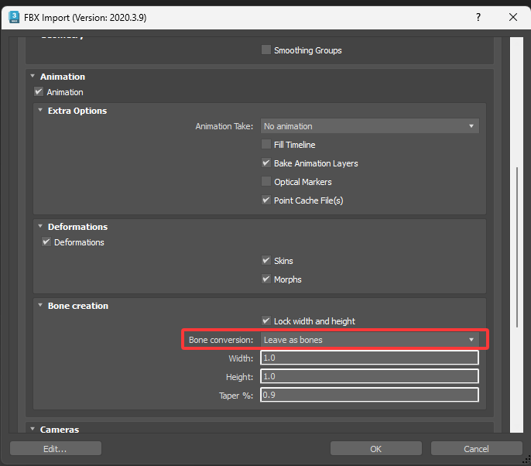
图 2 / Figure 2

三、通用化后的结果 / 3. Result after generic conversion
使用通用化 FBX 转换，再配合 Leave as bones，MAX 可以得到正常显示的网格和标准 Bone 节点。图中人物网格、骨架位置和整体显示均恢复到可检查状态。
After generic FBX conversion and with Leave as bones enabled, MAX can display the mesh and standard Bone nodes correctly. The figure, skeleton placement, and overall display return to a usable state.
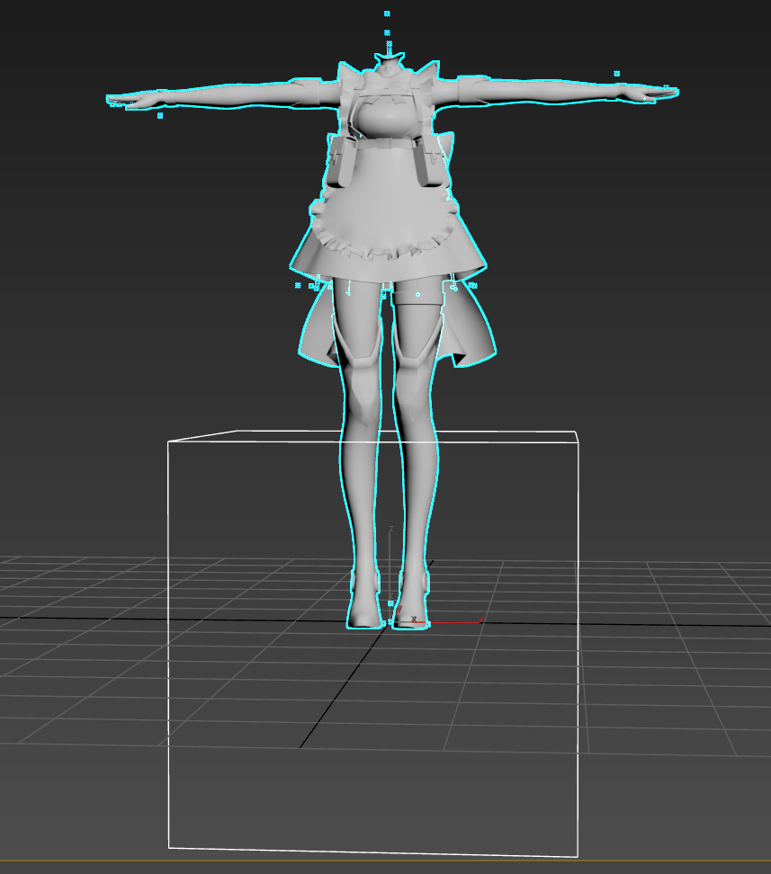
图 3 / Figure 3
下载通用 FBX 转换器 / Download Generic FBX Converter
这里可以下载 Generic FBX Converter 通用 FBX 转换器.py：https://github.com/Criticise/PC-REHD-1.2.8-Scrpit-rewritten-in-Python-by-Code-X-GPT-5.6/releases/tag/v1.0.0

